National Textile University, Faisalabad
Department of Computer Science
Machine Learning: AIC-3072
Reading Notes to in addition to Slides
Week 2
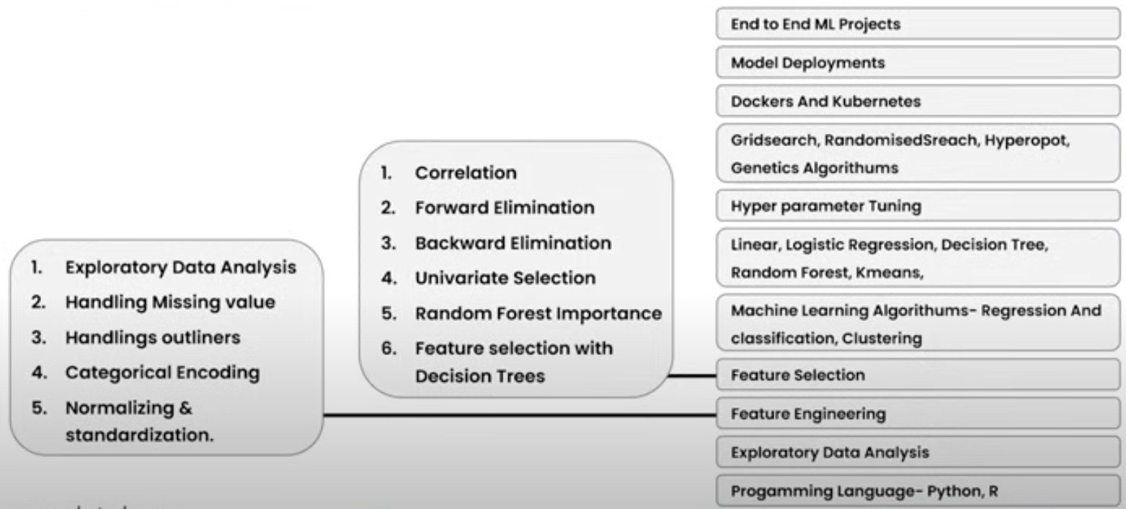
What do you need to implement machine learning?

What popular Python libraries do we use for Machine Learning?


A mini quick reference sheet — table with purpose, import, and one-line usage example for each library:
Library | Main Purpose / Use | Import Example | One-line Usage Example
NumPy | Numerical computing and array operations | import numpy as np | arr = np.array([1, 2, 3])
Pandas | Data manipulation and analysis (tabular/structured data) | import pandas as pd | df = pd.DataFrame({'A':[1,2], 'B':[3,4]})
Matplotlib | Basic data visualization and plotting | import matplotlib.pyplot as plt | plt.plot([1,2,3],[4,5,6]); plt.show()
Seaborn | Advanced statistical visualization | import seaborn as sns | sns.histplot([1,2,2,3,3,3,4])
Scikit-learn | Machine learning models | from sklearn.linear_model import LinearRegression | model = LinearRegression().fit([[1],[2]], [1,2])
SciPy | Scientific computing, math, constants | from scipy import constants | g = constants.g
TensorFlow | Deep learning & neural networks | import tensorflow as tf | x = tf.constant([1,2,3])
PyTorch (optional) | Deep learning (research/industry) | import torch | x = torch.tensor([1,2,3])
NLTK | Natural language processing (NLP) | import nltk | tokens = nltk.word_tokenize("Hello World")
OpenCV | Computer vision, image & video processing | import cv2 | img = cv2.imread("image.jpg")

Data/variable/feature/attribute types in Machine Leanrning
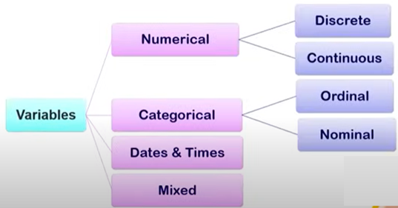

1. Numerical (Quantitative) Variables
These represent measurable quantities.
- Continuous → Values can take any number within a range (e.g., height, temperature, salary).
- Discrete → Values are countable integers (e.g., number of children, number of cars).

2. Categorical (Qualitative) Variables
These represent labels or categories.
- Nominal → Categories with no inherent order (e.g., gender, color, city name).
- Ordinal → Categories with a meaningful order/ranking (e.g., education level, customer satisfaction ratings).

3. Binary Variables
A special case of categorical variables with only two possible values (e.g., Yes/No, 0/1, True/False).

4. Time-Series / Temporal Variables
Data recorded over time (e.g., stock prices, weather data, patient heart rate over time).

5. Text Variables
Unstructured string/text data (e.g., customer reviews, tweets, documents). Usually processed with NLP techniques.

6. Image / Video Variables
Pixel values, frames, or embeddings representing visual data (used in computer vision).

7. Derived / Engineered Variables
New variables created from existing ones (e.g., BMI = weight/height², age group from age).

Continuous (Height cm) | Discrete  (No. of Children) | Nominal (City) | Ordinal (Education Level) | Binary (Smoker) | Time-Series (Stock Price) | Text (Review) | Image/Video (File Name) | Derived/Engineered (BMI)
172.4 | 2 | Lahore | Bachelor | Yes | 2025-01-01: 105.2 | Great product | img_001.jpg | 22.5
165 | 0 | Karachi | Master | No | 2025-01-02: 107.8 | Too expensive | img_002.jpg | 24.1
180.3 | 3 | Faisalabad | Intermediate | Yes | 2025-01-03: 103.5 | Loved it | img_003.jpg | 26.4
158.7 | 1 | Multan | PhD | No | 2025-01-04: 110.0 | Not bad | img_004.jpg | 20.9
170.2 | 4 | Islamabad | Matric | Yes | 2025-01-05: 101.7 | Excellent | img_005.jpg | 28.3
162.9 | 2 | Quetta | Bachelor | No | 2025-01-06: 108.9 | Could be better | img_006.jpg | 23
177.1 | 0 | Peshawar | Master | Yes | 2025-01-07: 106.4 | Very useful | img_007.jpg | 25.7
155.8 | 1 | Hyderabad | Intermediate | No | 2025-01-08: 104.2 | Poor quality | img_008.jpg | 19.8
168.5 | 2 | Sialkot | PhD | Yes | 2025-01-09: 109.5 | Amazing | img_009.jpg | 27.2
174.6 | 3 | Gujranwala | Matric | No | 2025-01-10: 102.1 | Worth it | img_010.jpg | 21.6

What is Data Cleaning in Machine Learning?
Data cleaning (or data preprocessing) is the process of detecting and correcting (or removing) errors, inconsistencies, and missing values in a dataset before training a machine learning model.
Since "garbage in → garbage out", high-quality data is critical for building accurate and reliable ML models.

🔹 Common Issues in Raw Data
- Missing Values – Some entries may be empty (e.g., age = NaN).
- Duplicate Records – Same row repeated multiple times.
- Inconsistent Data – Different formats for the same thing (e.g., "USA" vs. "U.S.A.").
- Outliers – Extremely large or small values that don’t fit the pattern.
- Noise – Random errors or irrelevant data.
- Unbalanced Classes – In classification, one class dominates the dataset.
- Incorrect Data Types – e.g., numbers stored as text.
Why Data Cleaning is Important?
- Improves model accuracy
- Reduces bias
- Prevents overfitting/underfitting
- Makes training faster and more efficient
Data cleaning is the first and most important step in ML pipelines. Without it, even advanced models won’t perform well.

A practical Python example with Pandas and Scikit-learn to show common data cleaning operations.

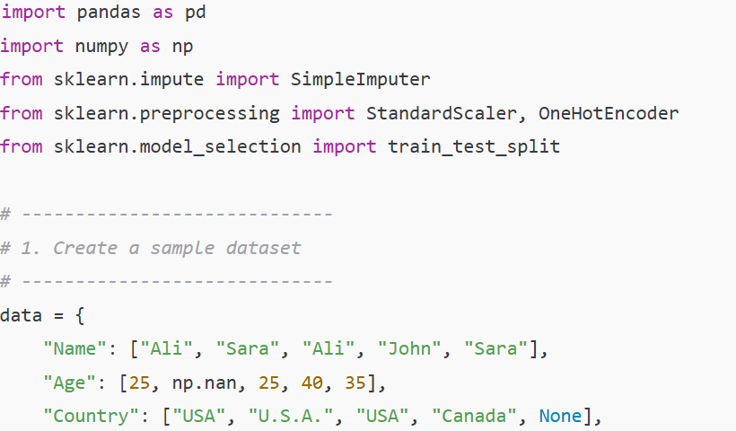
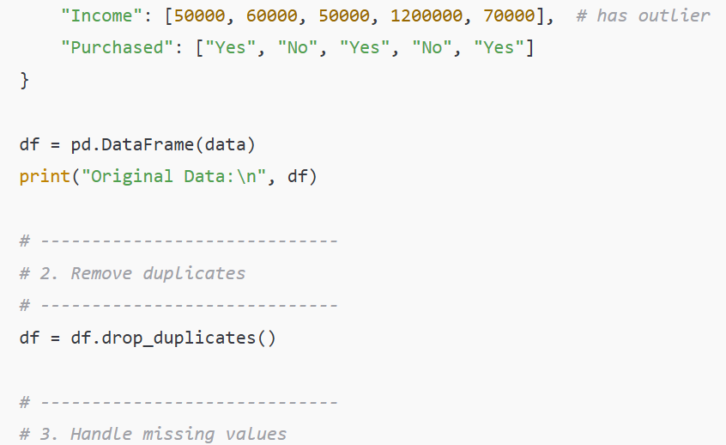
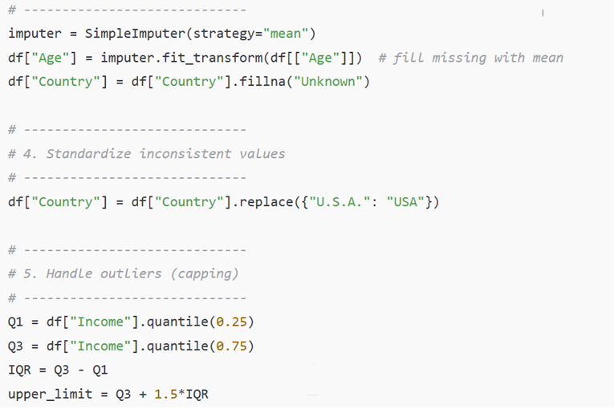
Full Code
import pandas as pd
import numpy as np
from sklearn.impute import SimpleImputer
from sklearn.preprocessing import StandardScaler, OneHotEncoder
from sklearn.model_selection import train_test_split

# -----------------------------
# 1. Create a sample dataset
# -----------------------------
data = {
"Name": ["Ali", "Sara", "Ali", "John", "Sara"],
"Age": [25, np.nan, 25, 40, 35],
"Country": ["USA", "U.S.A.", "USA", "Canada", None],
"Income": [50000, 60000, 50000, 1200000, 70000], # has outlier
"Purchased": ["Yes", "No", "Yes", "No", "Yes"]
}

df = pd.DataFrame(data)
print("Original Data:\n", df)

# -----------------------------
# 2. Remove duplicates
# -----------------------------
df = df.drop_duplicates()

# -----------------------------
# 3. Handle missing values
# -----------------------------
imputer = SimpleImputer(strategy="mean")
df["Age"] = imputer.fit_transform(df[["Age"]]) # fill missing with mean
df["Country"] = df["Country"].fillna("Unknown")

# -----------------------------
# 4. Standardize inconsistent values
# -----------------------------
df["Country"] = df["Country"].replace({"U.S.A.": "USA"})

# -----------------------------
# 5. Handle outliers (capping)
# -----------------------------
Q1 = df["Income"].quantile(0.25)
Q3 = df["Income"].quantile(0.75)
IQR = Q3 - Q1
upper_limit = Q3 + 1.5*IQR
df["Income"] = np.where(df["Income"] > upper_limit, upper_limit, df["Income"])

# -----------------------------
# 6. Encode categorical variables
# -----------------------------
encoder = OneHotEncoder(sparse=False, drop="first")
country_encoded = encoder.fit_transform(df[["Country"]])
country_df = pd.DataFrame(country_encoded, columns=encoder.get_feature_names_out(["Country"]))

df = pd.concat([df.drop("Country", axis=1), country_df], axis=1)

# -----------------------------
# 7. Scale numeric features
# -----------------------------
scaler = StandardScaler()
df[["Age", "Income"]] = scaler.fit_transform(df[["Age", "Income"]])

print("\nCleaned & Processed Data:\n", df)

